**Exercise 2: Implementing the Factory Method Pattern**

* **Step-1:** Created a Java project named **FactoryMethodPatternExample**.
* **Step-2**: Created Interface class

**Document.java**

public interface Document {

    public void open();

    public void write();

}

* **Step-3:** Concrete Document Classes

**WordDocument.java**

public class WordDocument implements Document {

    public void open() {

        System.out.println("Opening Word Document");

    }

    public void write() {

        System.out.println("details of girish written into word document");

    }

}

**PdfDocument.java**

public class PdfDocument implements Document {

    public void open() {

        System.out.println("Opening Pdf Document");

    }

    public void write() {

        System.out.println("details of girish written into pdf document");

    }

}

**ExcelDocument.java**

public class ExcelDocument implements Document {

    public void open() {

        System.out.println("Opening Excel Document");}

    public void write() {

        System.out.println("details of girish written into Excel document");

    }

}

* **Step-4:** Created an abstract class **DocumentFactory** with a method **createDocument()**.

**DocumentFactory.java**

public abstract class DocumentFactory {

    public abstract Document createDocument();

}

**WordFactory.java**

public class WordFactory extends DocumentFactory {

    public Document createDocument() {

        return new WordDocument();

    }

}

**PdfFactory.java**

public class PdfFactory extends DocumentFactory {

    public Document createDocument() {

        return new WordDocument();

    }

}

**ExcelFactory.java**

public class ExcelFactory extends DocumentFactory {

    public Document createDocument() {

        return new WordDocument();

    }

}

* **Step-5:** testing the program

**Factory_test.java**

public class Factory_Test {

    public static void main(String[] args) {

        DocumentFactory wordFactory = new WordFactory();

        Document word = wordFactory.createDocument();

        word.open();

        word.write();

        DocumentFactory pdfFactory = new PdfFactory();

        Document pdf = pdfFactory.createDocument();

        pdf.open();

        pdf.write();

        DocumentFactory excelFactory = new ExcelFactory();

        Document excel = excelFactory.createDocument();

        excel.open();

        excel.write();

    }

}

**Output:**

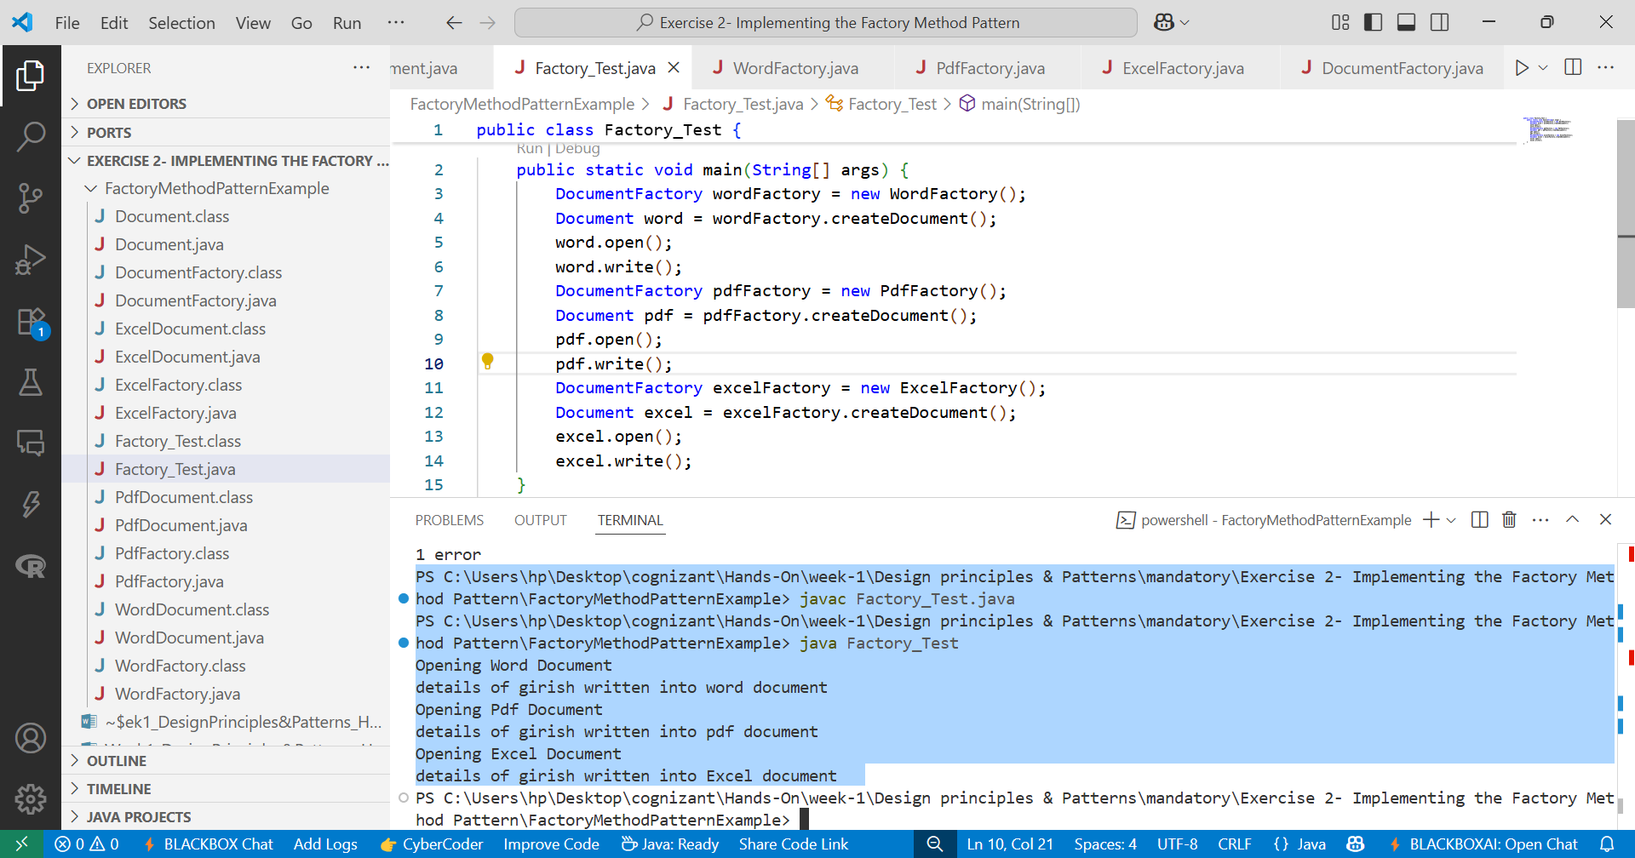

Fig-1 Factory_Test.java file with Program Output